Welcome!
Date
Name
Spouse
Address
City
State Zip _________
Email

Please Contact By
❑ Card  Phone  Visit

Telephone Best Time to Call
Home ______________
Work ______________

Guest: First Time Second Time
Are you a church member: yes no
Church
City, State

Circle Appropriate Age/Grade Group(s)
Preschool: Ages: B-1 2-3 4-5
Children: Grades: K 1 2 3 4 5 6
Youth: Grades: 7 8 9 10 11 12
Adults: Ages:18-29 30s 40s 50s 60s+

How did you learn about our church?
Newspaper Friend Yellow Pages Mail
Other

I am a guest of:

New in the Community? Yes No
Names & ages of children at home

Weekly Service & Activity Schedule

Oct 9, 2016

9:30 a.m. New Commandment Kids
10:00 a.m. Sunday School
11:00 a.m. Worship Service
6:00 p.m. Evening Service/Bus. Meeting

Week of Oct 9, 2016

Wednesday 6:30 pm……………………Meal/Bible Study
Thursday 10:00 am……………..……..Adult Fellowship

Upcoming Events
October
16…….…Annual Assoc.Mtg/Burleson Co. Cowboy Church
27……………………………………..……….Adult Fellowship
30……………………………………High Attendance Sunday
November
10……………………………………………..Adult Fellowship
12………………………………………………….Harvest Stew

New Commandment Kids

Ages Kinder thru 12th grade are welcome!
Hands-on mission work thru puppet ministry and crafts to share with nursing homes, shut-ins, etc.
Meeting the 1st and 2nd Sunday of each month @ 9:30 am


Join us for High Attendance Sunday
Oct 30. Bring a friend! The men will fix a great breakfast. More details to come!!

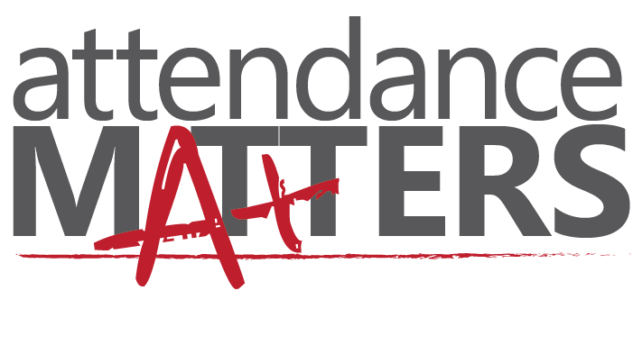

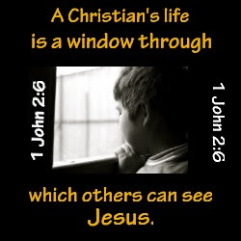

Knobbs Springs Baptist Church

October 9, 2016

Church Information:

KnobbsSpringsBC.com KnobbsSpringsBaptist@gmail.com

1662 CR 305, McDade, Texas 78650 512-273-2743

David Atwood, Pastor Cell 512-470-5098

Patti Radford, Office Manager Cell 512-968-7821

